
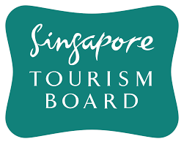

School of Engineering
Diploma in AI & Data Engineering

EGT204
DATA PREPARATION & VISUALISATION
Final Report
AY2024S1
Group 3: Marcus, Mattias, Samuel
date:11/8/24
Table of Contents
- Business Understanding
1.1 Determine Business Objectives
1.2 Situation Assessment
1.3 Data Mining Goals
- Data Understanding
2.1 Overview of Data Sources
2.2 Data Exploration
2.3 Data Dictionary
- Data Preparation
3.1 Data Cleaning Report
- Data Visualization
4.1 Dashboard 1: Tourist Demographics
4.2 Dashboard 2: Tourism Receipts
4.3 Dashboard 3: Revenge Tourism
- Analysis
5.1 Dashboard 1: Tourist Demographics (Analysis)
5.2 Dashboard 2: Tourism Receipts (Analysis)
5.3 Dashboard 3: Revenge Tourism (Analysis)
- Overall Results

- Conclusion
- Contributions
- Appendix

1.Business Understanding:
1.1: Determine Business Objectives
Tourism plays a huge part in Singapore’s economy. As of 2023, it is worth 4% of Singapore’s Gross Domestic product (GDP). This is equivalent to 27.2 billion SGD. Tourism also provides a livelihood to people by providing jobs, such as tour guides, air stewardesses and gift shop owners.
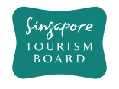
Singapore Tourism Board, STB, is responsible for planning, developing, and marketing tourism in Singapore. Its primary objective is to promote Singapore as a compelling destination for leisure and business travellers. Not only that, it also collaborates with various stakeholders in the tourism industry, including hotels, attractions, airlines, travel agencies, and event organisers, to enhance Singapore's tourism offerings and experiences. Overall, the Singapore Tourism Board (STB) works towards attracting visitors, generating tourism revenue, and enhancing Singapore's tourism rate.
Figure 1: Logo of Singapore Tourism Board
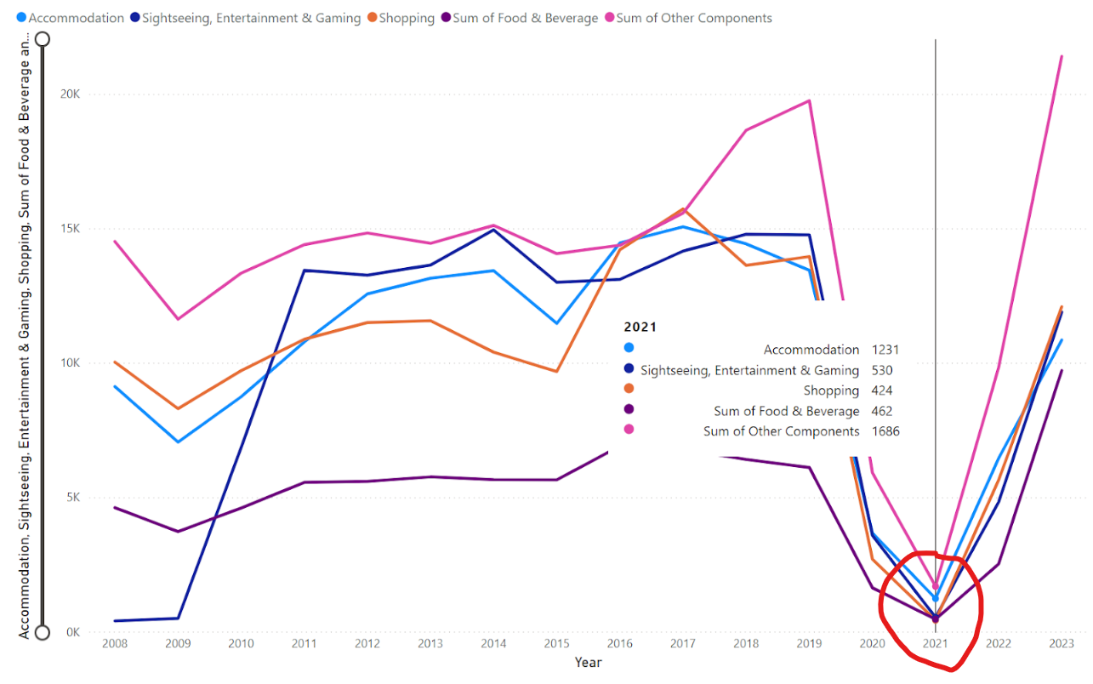
Figure 2:Huge drop in tourist arrivals and revenue. Source: Self Created Line graph using source from: https://tablebuilder.singstat.gov.sg/table/TS/M550371#
According to the Singapore Tourism Board, in 2020, during the COVID-19 pandemic, Singapore’s tourism sector took a massive hit, losing large amounts of tourist revenue and international arrivals. This decrease in tourist receipts has caused Singapore’ economy to struggle, as tourist revenue plays a huge part in Singapore’s economy and GDP (4%). As of today, Singapore’s tourism sector has greatly recovered, but how can we ensure that Singapore is able to not only fully recover from the hit but also keep on sustaining the levels of growth and surpass all previous levels?

Therefore, our problem statement for this project is to ensure that Singapore’s tourism sector can recover from the Covid-19 hit and is able to sustain continuous growth even after recovery. To do so, we must ensure that the Tourist Arrival Rate and the Tourist Receipts (Spendings) continue to increase.
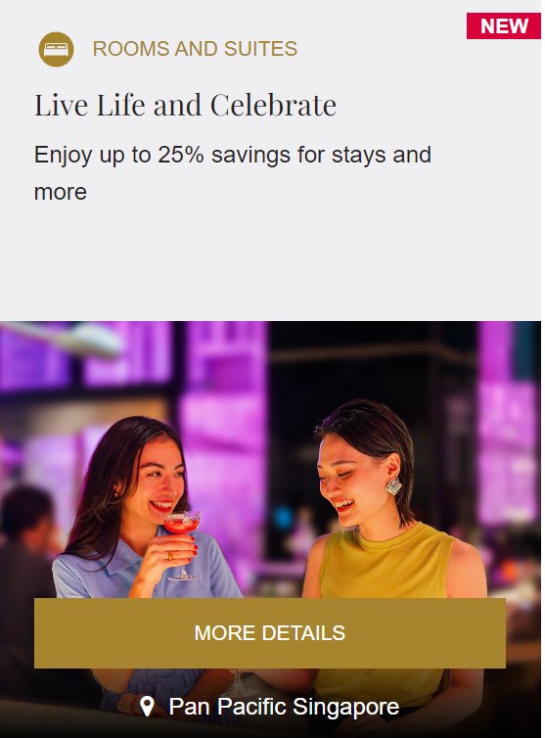
Figure 3:Pan Pacific poster: Creation of promotions or opportunities
Our business objective is to identify factors (e.g. Tourist Demographics and Tourist Receipts), that will have tourists more attracted to come to Singapore to spend their holiday touring here instead of other countries. With proper use of these factors, it can lead Singapore to higher tourist arrivals and spendings. Through the creation of promotions or opportunities, it can convince them to willingly spend their money on, therefore allowing Singapore’s tourism sector to recover and grow even further (sustainable growth).
1.2 Situation Assessment
To accomplish this business objective, we have collected the required resources we can work with. For data, we will be using data from SingStat, an official government agency website. Our requirement is to submit all our work by 12/8/24 11.59pm. Some constraints we had is that some of the data online was locked behind a paywall. Some risks that may lead to project failing could be due to lack of time. Hence, we started this project as early as we can.
For Software:


- Google Colab to clean the data
Figure 4: Power BI Logo
Figure 5: Google Colab Logo
- Excel to store the data
- Power BI to create dashboards

1.3 Data Mining Goals

- Tourist Demographic. Identify the types of tourists
Figure 6: Example of promotions- entertainment for kids
travelling to Singapore. This section includes identifying the gender, age group and country of arrival and finding the top demographics.
With these identification and information, it will allow us the ability to determine the likings to these demographics and tailor our promotion/discounts based on these likings. For example, if there is a large number of children (<15 years old) coming to Singapore, we now know that children tend to be more attracted to come to Singapore. As such, we can make use of this knowledge and set up promotions/discounts in entertainment for kids, such as amusement parks and carnivals. This will in turn further draw out the potential of this “attraction”, leading to more children coming to Singapore. Therefore, increasing tourists’ arrivals and revenue.
- Tourist Receipts.: Identify the topmost popular spendings by tourists. This section includes identifying what are the top earning categories, such as accommodation, shopping or food and beverages, and the time span of the year which has the highest spendings by tourists.

With this information at hand, we are able to determine which category is the most crucial to tourists when touring and when their sales peaks. And with it, we are able to find out the types of promotions/discounts to put up (Based on the most crucial category) and what time span of the year should it last (Based on peak sales analysis). This will encourage more spending by tourists on these respective categories. For example, If the category “Shopping” has a very high volume in The Tourist Receipts, we can then make a reliable assumption that Shopping is a must when touring in Singapore. As such, promotions/discounts for items (e.g. clothes) can be put up on malls and stalls during the time span where tourist activity peaks in the year, pushing for more sales from these tourists and increasing our profit margin. This will be able to help us attract more sales through leveraging on the most popular category and potentially, more arrivals. Yielding great benefits for
Figure 7: Example of promotions and discounts for items- Recoil Poster
Singapore.
- Identify Revenge Tourism
Revenge tourism refers to the sharp increase in tourist activity immediately after a period of restrictions, such as lockdowns. People are more willing to pay more to travel in order to make up for lost time.
In 2020, Singapore was on lockdown due to COVID-19. Tourists were unable to come to Singapore. Therefore, when Singapore reopened, more tourists were willing to come to Singapore despite higher costs. Singapore is able to exploit this opportunity by increasing prices further, therefore increasing Singapore’s tourist receipt without affecting arrival rates significantly. However, it has been 3 years since Singapore reopened. Can Singapore still use Revenge Tourism?
Hence, our data mining goal is to find out if Singapore can continue to utilise revenge tourism and increase the pricing for tourists (such as hotel room rates) in Singapore, for 2024 or 2025.
1.4 Project Plan
- Business understanding -6hours
- Data understanding- 12 hours
- Data preparation- 15-20 hours
- Data Visualisation and Analysis- 20-30 hours
- Report and Presentation- 20-30 hours.
2. Data Understanding:
2.1 Overview of Data Sources
We have collected all 4 datasets from SingStat, the department of Statistics Singapore, a Singapore government agency website. (https://www.singstat.gov.sg/find-data/search-by-theme/industry/tourism/latest-data). The 4 data sets that we used are:
1. Tourist Country of Arrival: https://tablebuilder.singstat.gov.sg/table/TS/M550001
Description: This data set shows the different countries the tourists coming to Singapore are from. This will help with achieving our Data Mining Goal 1.
2.Tourist Receipts/ Spendings: https://tablebuilder.singstat.gov.sg/table/TS/M550371#
Description: This data set shows the categories/type of things tourists spend their money on in Singapore. This will help with achieving our Data Mining Goal 2 and 3.
3.Tourist Demographics (age/gender etc): https://tablebuilder.singstat.gov.sg/table/TS/M550241
Description: This data set shows the type of tourists coming to Singapore (e.g. Gender, Age). This will help with achieving our Data Mining Goal 1.
4.Hotel Stats: https://tablebuilder.singstat.gov.sg/table/TS/M550081
Description: This data set shows the hotel statistics (e.g. revenue, room rate etc.), of tourists spendings. This will help with achieving our Data Mining Goal 2 and 3.
2.2 Data Exploration
We begin our data understanding by inspecting the data. Upon inspection, we realised that there were a lot of empty rows in the data sets. These were spaces used to write footnotes and credit data sources.
We also realised we need to transpose the data, as the rows and columns are swapped. The quarters, which should act as the index, were the columns.
There were many “na” values, especially in the Country of Arrival dataset, which means that the data is not available or applicable. In this project, we will consider these data as 0. Hotel stats and tourist receipts have their data in millions of dollars, we should take note of this when analysing our data.
In order to further explore and understand the data we collected, we have created a data dictionary for the 4 data sets, recording the data types, any additional information, descriptions and examples of the fields.
2.3 Data Dictionary
Data Dictionary
Data Set | Field Name/ Areas | Countries included | Data Type | Description | Example
Country of Arrival | Date | - | object | Year and Month - YYYY M | 2022 Jun
 | Southeast Asia | Brunei Darussalam, Indonesia, Malaysia, Myanmar, Philippines, Thailand, Vietnam, others in SEA. | object | Total Arrivals per month in SEA | 450954
 | Greater China | China, Hong Kong, Taiwan, others in GC. | object | Total Arrivals per month in GC | 277309
 | North Asia | Japan, South Korea, others in NA | object | Total Arrivals per month in NA | 73476
 | South Asia | Bangladesh, India, Pakistan, Sri Lanka, others in SA. | object | Total Arrivals per month in SA | 143127
 | West Asia | Iran, Israel, Kuwait, Saudi Arabia, United Arab Emirates, others in WA | object | Total Arrivals per month in WA | 16006
 | Americas | Canada, USA, others in America | object | Total Arrivals per month in America | 75894
 | Europe | Belgium and Luxembourg, Denmark, Finland, France, Germany, Italy, Netherlands, Norway, Rep of Ireland, Russian Federation, Spain, Sweden, Switzerland, United Kingdom and others in Europe | object | Total Arrivals per month in Europe | 101853
 | Oceania | Australia, New Zealand, others in Oceania | object | Total Arrivals per month in Oceania | 105430
 | Africa | Egypt, Mauritius, South Africa, others in Africa | object | Total Arrivals per month in Africa | 5411
 | Others | Other countries not mentioned previously | object | Total Arrivals per month for others. | 806

Data Dictionary
Data Set | Field Name | Data Type | Additional info | Description | Example
Tourist Receipts | Date(Q) | Object | YYYY Q | Year and Quarter of Data | 2023 Q4
 | Tourism Receipts | Float  (64) | In millions | Overall tourist spendings, Sum of all 5 components | 27157.0
 | Accommodation | Float  (64) | In millions | Tourist spendings on accommodation- Hotel, Airbnb etc. | 4471.0
 | Food & Beverage | Float  (64) | In millions | Tourist Spendings on Food and Beverage | 3976.0
 | Shopping | Float  (64) | In millions | Tourist Spendings on Shopping/ Retail etc. | 4954.0
 | Sightseeing, Entertainment & Gaming | Float  (64) | In millions | Entrance fee to nightclubs, attractions, day trip expenditures and gaming expenditures | 5065.0
 | Other Components | Float  (64) | In millions | Airfares, transport, medical, business, port taxes and education, etc. | 8690.0

Data Dictionary
Data Set | Field Name | Includes: | Data type | Description | Examples
Tourist  Demo-  graphic | Date | - | object | Year and Month - YYYY M | 2024 May
 | Age Groups | <15 Y.O., 15-19 Y.O., 20-24 Y. O., 25-34 Y.O., 35-44 Y. O., 45-54 Y.O., 55-64 Y.O., >65 Y.O. | object | Arrivals of age groups by month | 136467
 | Total | Age groups, Males, Females | object | Total Arrivals per month | 1250266
 | Male | - | object | Male arrivals monthly | 603092
 | Female | - | object | Female Arrivals monthly | 646951

Data Dictionary
Hotel Statistics | Field Name | Additional Info | Data Type | Description | Examples
 | Date | YYYY M | Object | Year and Month - YYYY M | 2021 Jan
 | Hotel Room Revenue | In thousands | Float  (64) | Hotel Revenue of that  certain Month | 440574.4
 | Standard Average Room Rate | In dollars | Float  (64) | Cost of Hotel room per night. | 280
 | Gross Lettings (Room Nights) | In numbers | Float  (64) | Number of rooms are occupied that month (Calculated based on Nights) | 1572689
 | Available Room Nights | In numbers | Float  (64) | Number of rooms are empty that months  (Calculated based on Nights) | 1979712
Data Exploration:
While exploring the dataset country of arrival, we realised that the top countries (not areas, countries.)

3. DATA PREPARATION:
Data Cleaning Report
As all 4 datasets had footnotes or credits at the front or back of the data, we needed to slice the columns so that we could get the actual data. We used most of the data in the datasets, with some exceptions, for example, some of the countries in Country-Of-Arrival, as there are too many countries. Hence, we only looked at the top 5 countries and areas.
Country of Arrival:
The data for the country of arrivals was originally organised by dates as columns. We first restructured the data to make the countries the columns. We then filtered the data to retain records from 2008 and onwards, ensuring consistency with the dataset that only included data from 2008 and beyond. Additionally, we separated the date and month.
- Total Entries: 558, Kept Entries: 192
- Missing Entries: 0 (0%), Duplicated Entries: 0 (0%)
Tourist spendings:
We separated the date and month and checked for any duplicate data.
- Total Entries: 64, Kept Entries: 64
- Missing Entries: 0 (0%), Duplicated Entries: 0 (0%)
Tourist demographic
The tourist demographic data was originally organised by dates as columns. We restructured the data to make the demographics the columns. We then filtered the data to retain records from 2008 and onwards and removed data from 2024 as it was incomplete.
- Total Entries: 198, Kept Entries: 192
- Missing Entries: 0 (0%), Duplicated Entries: 0 (0%)
Hotel statistic
We merged the tourist spending data with the hotel statistics data for analysis. We also aggregated the data by quarters to facilitate comparison with tourist spendings.
- Total Entries: 192, Kept Entries: 64
- Missing Entries: 0 (0%), Duplicated Entries: 0 (0%)
We also ensured that the units of the data are uniform across all data sets. For example, changing” Hotel Room Revenue” from Hotel Statistics from thousands of dollars to millions of dollars so that we can compare it with the data in Tourist Spendings, as the data is in millions of dollars.

Summary for data preparation
Apart from formatting the data and converting missing values (NA) to 0, there were no missing or duplicated entries across all four datasets. The primary data cleaning activities involved formatting the data and removing all footnotes and remarks.

4. Data Visualisation
4.1 Dashboard 1: Tourist Demographics:
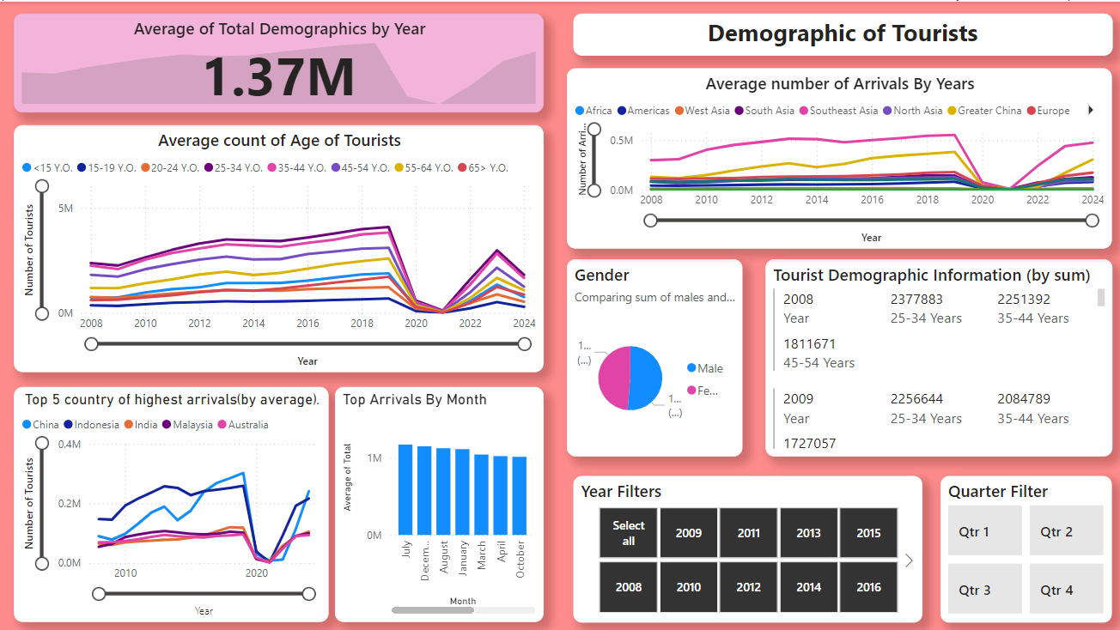
Figure 8: Dashboard 1- Tourist Demographics- Done by Marcus
1. Gender of Tourists: In this graph, we are trying to look at the distributions between male and female tourists coming to Singapore, so that we can see if there are more males or females arriving in Singapore. As we are looking at distribution between males and females, we will need to use a pie chart. We will be using the “Males” and “Females” column from the dataset Tourist Demographics.
2. Average count of Age of tourists: In this graph, we are trying to look at the number of tourists coming to Singapore based on age, so that we can see which age groups are the top tourists of Singapore. As we are looking at trends, a line graph is best suited to present the graph. We will be using the age group columns from the dataset Tourist Demographics. We added a KPI, key performance indicator to show the average total demographics per year, which can be compared to the line graph to see whether the number of tourists coming for that age group is above or below average.
3. Average number of tourists by area: In this graph, we are trying to see where the tourists are arriving from by area. As we are using trends again, a line graph is used for the graph. We will use the columns: “Southeast Asia”, “South Asia”, “West Asia”, “North Asia”, “Europe”, “Africas”, “Americas”, “Oceania”, “Europe” and “Others”, from the dataset Country of Arrival.
4. Average number of tourists by country: Although this is like the graph “Average number of tourists by area”, we wanted to present the top 5 countries. As we found the top 5 countries previously while data exploration, we used the columns: “China”, “India”, “Indonesia”, “Malaysia” and “Australia” from the dataset Country of Arrival. We used line graphs to showcase the trends of arrivals.
5. To allow users to filter out for time periods that they prefer, we added a year filter and a quarter filter. The year filter allows users to select all the years (2008-2024), while the quarter filter allows users to select from 4 quarters (Q1-Q4). We added a multi-row card to the dashboard as well. This allows the user to look at the top age groups with ease. While the line graphs show the data in average, the multi-row card has the data in sum.
There is a drill down function in all 3 line graphs, allowing users to look at years, quarters and months individually.
4.2 Dashboard 2: Tourism Receipt
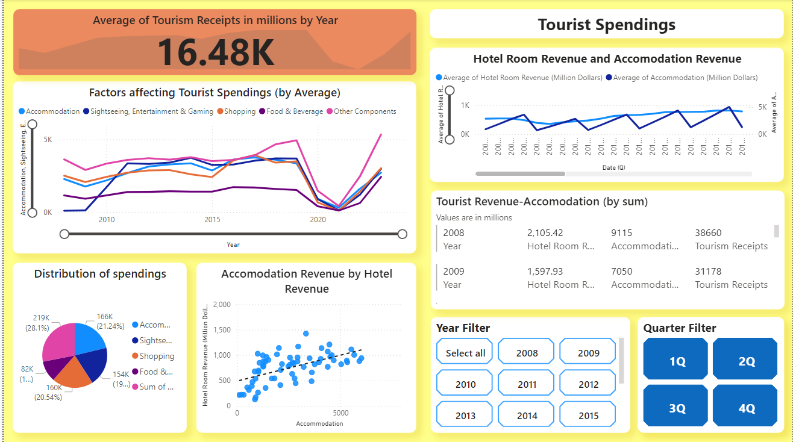
Figure 9: Dashboard 2: Tourist Receipt- Done by Mattias
Unless specified, all data used in this dashboard are from the dataset: “Tourist Spendings.”
1. Distribution of Factors affecting Spendings: In this chart, we are looking at the 5 factors affecting tourist spendings by sum. As we are looking at distribution, a pie chart is best suited for this. The 5 columns used are: “Accommodation”, “Sightseeing, Entertainment and Gaming”, “Shopping”, “Food and Beverage” and “Other Components”.
2. Factor affecting tourist spendings (by average): In this chart, we are looking at the 5 factors affecting tourist spendings on average as well. As we are looking at trends in this graph, we used a line graph for this chart.
3. In factors affecting tourist spendings, Accommodation is one of the factors that affects tourist spendings by a lot. Not only is it one of the top 2 factors affecting tourist spendings (first one being others, which is too vague), it also has one of the steepest increases in spendings as compared to the other factors. Hence, to further analyse tourist receipts, we would need to look at hotel spendings as well.
4. In hotel revenue and Accommodation revenue, we looked at the average of hotel revenue (from Hotel Spendings) and average of Accommodation revenue (from Tourist Spendings), as these two factors are closely related. As we are looking by trends, we used a line graph. We also created a scatterplot on these two factors as well, so that we can see the correlation between them.
5. A multi row card was used for users to view both the sum of accommodation and hotel revenue. Like the first dashboard, a quarters and years filter were made for the user.
4.3 Dashboard 3: Revenge Tourism
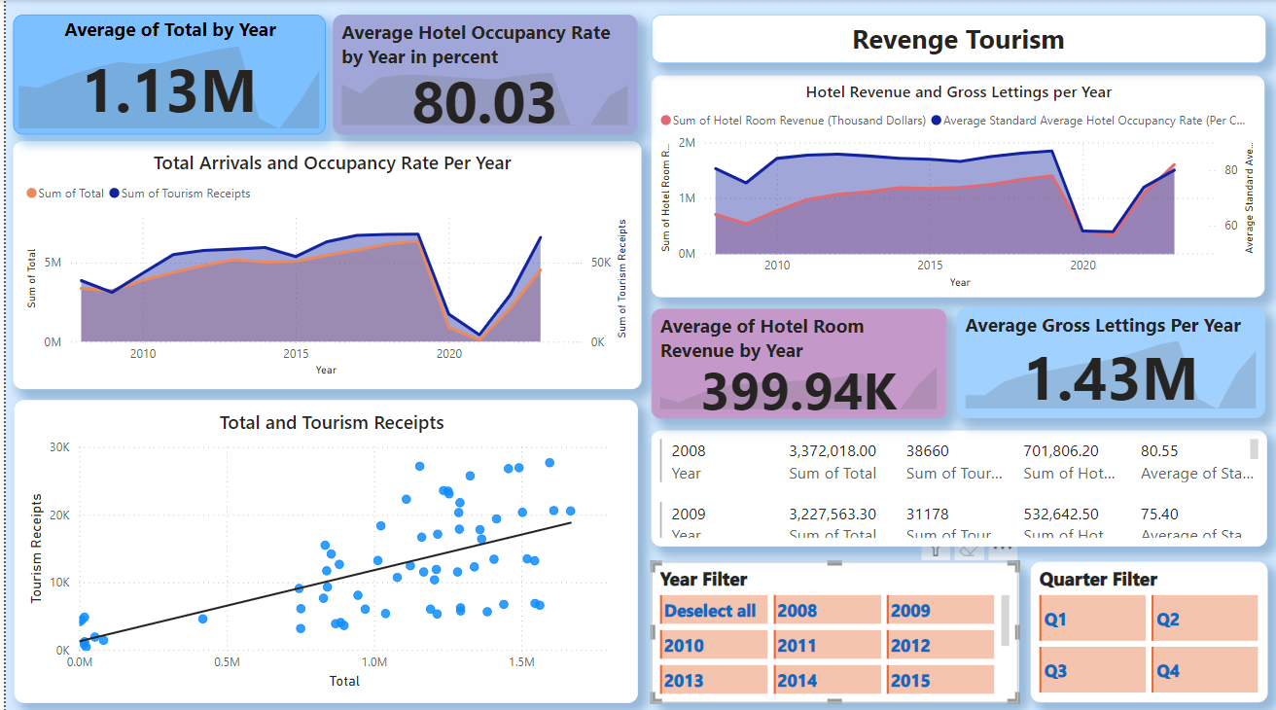
Figure 10: Dashboard 3: Revenge Tourism- Done by Samuel
1. Hotel Revenue and Gross Lettings per year: We wanted to see hotel revenue and occupancy rate grew together yearly. We used an area line chart to see the area between the 2 data. The higher the area in between, the higher it suggests the higher revenge tourism will be. In this graph, we looked at the columns “Hotel Room Revenue” and “Gross Lettings” from the data set “Hotel Stats”.
2. Total Arrivals and Occupancy Rate per year: We wanted to see both the Hotel Revenue and Gross Lettings per year: We used an area line chart here as well so that we can see the area in between the 2 data. The higher the area in between, the higher it suggests the higher revenge tourism will be. In this graph, we looked at the columns “Hotel Room Revenue” and “Occupancy Rate” from the data set “Hotel Stats”.
3. We created a scatter plot to look at the correlation between total arrivals (from tourist demographics) and overall tourism receipts (from tourist receipts)
4. Like the other dashboards, we also created a quarter and years filter for the user.
5. We also created KPI for 4 data, “Total Arrivals” from Demographic of Tourists, “Hotel Occupancy Rate”, “Hotel Revenue” and “Gross Lettings” from “Hotel Stats”. This allows users to see the average per year of these datasets.
5. Analysis:
5.1 Dashboard 1: Demographics of Tourists:
1. Gender of Tourists: The genders of tourists are divided almost evenly, between males (51.33%) and females (48.67%).
2. Age of Tourists: Upon first inspection, we realised that the majority of the tourists coming to Singapore are all working adults. With reference to 2023’s data, the top 3 age groups are: 25-34 Years old (2.98 million tourists), 35-44 Years old (2.83 million tourists) and 45-54 Years old(2.15 million tourists). We can focus on creating promotions and deals catered towards the 25–54-year-olds, such as sightseeing or MICE tourism.
3.Country of Arrival of tourists: Upon first inspection, we realised that a large majority of tourists come from Southeast Asia. The top 5 countries (with reference to 2023’s data by average) that tourists often arrive from were China (Greater China, 113K), India(Southeast Asia, 89K), Indonesia(Southeast Asia, 191K), Malaysia(Southeast Asia, 90K) and Australia(Oceania, 90K). We can create promotions or deals based on these demographics. For example, we can alter the plane tickets from China or India to Singapore, therefore attracting more tourists to come to Singapore.
4.Top months of arrival of tourists: We realised that the top 3 months where tourists often arrive were all at the latter half of the year (Quarter 3 and quarter 4). The top 3 months were July, with an average of 1.17m arrivals per year, December, 1.15 million arrivals per year, and August, with an average of 1.13 million arrivals per year. This means we should create promotions during these periods where tourists are more likely to come to Singapore to spend money.

5.2 Dashboard 2: Tourism Receipts
1. Out of all the Tourist Spendings categories, we can see that “Sum of other components” and “Accommodation” rank 1st and 2nd respectively. However, due to “Sum of other components” being a sum of many unlisted categories, we will not use it in our analysis. Hence, we will be using our 2nd ranked, “Accommodation”.
2. “Accommodation” revenue trend is generally stable, without any inconsistencies, from 2008 (9115M, pre-covid) to 2019 (13440M, pre-covid). However when covid hit in 2019, it caused a massive drop from 2019 (13440M, pre-covid) to 2021 (1231M, covid lockdown). When lockdown was lifted, it caused an explosive growth from 2021 (1231M, covid lockdown) to 2023(10849M, post-covid).
3. Since we are using “Accommodation”, we will be considering the largest factors that make up “Accommodation”. The largest factor will be “Hotels”, standing at 49% of all “Accommodation”. Hence, we will be using “Accommodation” as our key point. (Side note: The hotel datasets are all from gazetted hotels, ones registered with the STB, Singapore Tourism Board)
4. Checking for correlation between “Accommodation” revenue and “Hotel Room” revenue. There is a strong proportionate relationship between “Accommodation” revenue and “Hotel Room” revenue. Hence the data of hotels is a reliable subset of data of Accommodation.
5. Seeing the peak “Accommodation” revenue and “Hotel Room” revenue within a year by taking the average of every year from 2008 to 2023. “Hotel Room” revenue often peaks at Q3, whereas “Accommodation” revenue peaks at Q4. This suggests that peak tourism activity in Singapore per year is within the ranges of Q3 and Q4. There is, however, an outlier during the 2020-2021 period where “Hotel Room” revenue peaked in Q1, this is due to Covid.

5.3 Dashboard 3: Revenge Tourism
1.Total arrivals and occupancy rates show a general upward trend from 2008 to 2022. In 2008, total arrivals were at 3.37 million, with tourism receipts amounting to 38,660. By 2019, total arrivals increased to 6.37 million, and tourism receipts reached 68,004. However, there's a noticeable decline in both metrics around 2020 due to the global pandemic, with total arrivals plummeting to 110,019.60 and receipts dropping to 4,337 in 2021. Post-2020, there is a recovery trend, with total arrivals reaching 4.54 million and receipts at 65,929 in 2023
2.The correlation score for tourist receipt and total arrivals is 0.18, this means that there is low correlation between these two variables, this means there are other factors that affect total receipts other than just total arrivals, factors, may include an increase in spendings per tourist
3.hotel revenue and gross there is a general increase in both metrics from 2008 to 2019. In 2010, hotel room revenue was 767,186.10 thousand dollars with an occupancy rate of 64.23%. By 2019, revenue grew to 1.39 million thousand dollars, and the occupancy rate was 86.90%. There is a significant dip in both revenue and occupancy rate in 2020, but a recovery trend is visible post-2020. By 2023, hotel room revenue increased to 1.59 million thousand dollars, with an occupancy rate of 80.03%. This trend indicates the potential for leveraging revenge travelling as total arrivals have not yet reached pre-pandemic levels.
4.Looking deeper into pre covid we can see that from 2014 to 2018 the hotel room revenue was higher as compared to the room occupancy rate, looking into the reasons why, we found that there was multiple events being hosted in Singapore that drove up the revenue, an example of these events are the 2014 grand prix that was being hosted in Singapore, another major factor was the favourable exchange rate that was going on where in 2014 the exchange rate was up by more than 4 percent.
5.Looking into post covid the revenue is growing faster than the occupancy rate, as well as it not reaching the occupancy rate of pre covid level, this suggest that people are travelling more due to factors such as revenge travelling
6.Looking into dashboard 3 analysis, we can confidently conclude that due to factors such as room for growth as well as correlation and growth rates, we can leverage on revenge tourism by increasing hotel prices without deterring potential tourists, to boost sales and help recover the tourism sector.
6.Overall Results:
Through our analysis of the dashboards we can take out these factors that would answer our data mining goals, the first dashboard we identified 2 main factors of demographic, that being the dominant ages group being working adults that ranges from age 25-54,The majority of tourists come from Southeast Asia, particularly from India, Indonesia as well as China which is part of greater China, we also looked into the gender which did not have a significant role as it was almost split evenly between them, male being 51 percent whereas female at 49 percent, this suggest that we can cater to these group of demographic by creating special promotions.
For dashboard 2,we looked into the tourism receipts and found that accommodation contributes a large percentage as compared to the other sources of revenue, we then took a deep dive into accommodations and found that hotels plays a huge part of at a whopping 49% of total accommodations, there is a strong correlation between accommodation revenue and hotel room revenue, which further solidifies the our findings, through this we also found that hotel room revenue peaks at quarter3 ,while overall accommodations revenue peaks at quarter4, this suggest that during Q3 and Q4 we can find a strategy to attract customers during said peak months
Looking into dashboard 3 that is about revenge tourism, we can see that the tourism sector still have not recovered fully in terms of arrivals to pre pandemic levels, there is also a low correlation between tourist receipts and total arrivals, indicating that there are other key factors such as increased spendings per tourist, which can be seen in the recovery trend which the total hotel revenue is growing faster compared to the occupancy rates, this factor main contributor is due to revenge travelling, we also looked into past events such as favourable exchange rates and hosted events like the 2014 grand prix, this factors helped boost revenue in the past that could also affect the future.
7. Conclusion:
In conclusion, through this analysis of these 3 dashboards we can create several strategies such as promotions that are catered to the key demographics and age group, things that people ages 25-54 would enjoy, such as bird sightings. We can also create promotions and increase pricing during quarter 3 to 4 for things like hotel prices. We can also leverage revenge tourism by further increasing prices on hotels as people are willing to pay more. With these strategies, we can increase tourist receipt and arrival rate in Singapore, therefore allowing the Singapore tourism sector to recover smoothly and grow.
8. Contributions:
Mattias:
- Created dashboard 2
- Cleaned all 4 datasets via Google Colab
- Assisted with creation of slides
- Did the business understanding (background, data mining goals) in report
- Did data cleaning report
- Did data understanding portion of report
- Did analysis for dashboard 2
- Did overall results and conclusion for our report
Marcus:
- created Dashboard 1
- assisted in the creation of dashboard 2 and 3.
- Found the 4 datasets on Singstat
- Created 4 data dictionaries to explore the 4 datasets
- Did business understanding (Business Goals, access situation) portion of report
- Did the explanation (Data Visualisation) for dashboard 1, 2 and 3.
- Did the analysis for dashboard 1
- Assisted with creation of slides
Samuel:
- Created dashboard 3
- Made dashboard 1,2 and 3 look more presentable
- Explored the data on google Colab
- Did the data understanding portion of the report
- Did the data cleaning report
- Did the analysis for dashboard 3
- Did the results and overall conclusion for our report
- Created the slides and made the slides look presentable

9.Appendix

Figure 1: Logo of Singapore Tourism Board
https://www.stb.gov.sg/content/stb/en/media-centre/media-releases/Singapores-tourism-sector-posts-strong-recovery-in-2023-exceeds-forecasts-for-tourism-receipts.html.html

Figure 2: Huge drop in tourist arrivals and revenue. Source: Self-Created Line graph using source from: https://tablebuilder.singstat.gov.sg/table/TS/M550371#
Figure 3: Pan Pacific poster. Creation of promotions or opportunities Source: https://www.panpacific.com/en/hotels-and-resorts/pp-marina/offers.html
Figure 4: Power BI Logo. Source:https://apps.microsoft.com/detail/9ntxr16hnw1t?hl=en-us&gl=SG
Figure 5: Google Colab Logo Source: https://en.m.wikipedia.org/wiki/File:Google_Colaboratory_SVG_Logo.svg
Figure 6: Tayo Station poster. Example of promotions- entertainment for kids. Source: https://www.thrillophilia.com/collections/kids-activities-in-singapore-upto-20-off

Figure 7: Recoil on poster: Example of promotions and discounts for items- Recoil Poster Source: https://divedeals.sg/search

Figure 8: Dashboard 1- Tourist Demographics- Done by Marcus on PowerBI
Figure 9: Dashboard 2: Tourist Receipt- Done by Mattias on PowerBI
Figure 10: Dashboard 3: Revenge Tourism- Done by Samuel on Power BI

